**Rules for the Abstracts to be Presented at the 3rd International MiMETi4.0 Conference 2024**

**N. Lastname1*, N. Lastname1, N. Lastname1, N. Lastname1**

1Center for Engineering and Industrial Development. Playa Pie de la Cuesta 702, Desarrollo San Pablo, Queretaro, Mexico. 76125.* Corresponding author: [xxx@mail.mx](mailto:xxx@mail.mx)

**SESSION IN WHICH YOU WISH TO PARTICIPATE:**

__ Technological elements of industry 4.0

__Smart manufacturing

__ Mechatronic

**CONTRIBUTION TYPE**

__ Plenary conference

__ Oral

__ Poster

**ABSTRACT**

This template shows the abstract’s format for submitting to the 3rd MIMETI 4.0 Conference 2024, held on October 29-31. The abstract must have a maximum length of 250 words, including concisely: goals, scope and motivation.

**KEYWORDS**: Maximum 3 keywords, definitions, words.

**INTRODUCTION**

This section should include a brief description of the elements necessary to understand the problem and how your work contributes to the solution. The introduction must have a maximum length of 300 words

**METHODOLOGY**

The methodology must include the necessary conditions to understand the development of the research and other relevant technical information. a maximum of 2 tables can be included if necessary. The maximum length of the methodology is 300 words.

**RESULTS**

The results must clearly show the contributions made to the research topic. A maximum of 3 figures and 5 references can be included. The maximum length of the item is 500 words.

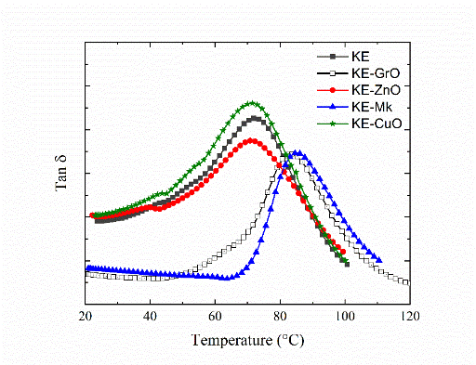

**Figure 1.** Please maintain the figure legends in the format.

**Table 1.** Please maintain the table format

|  |  |  |  |
| --- | --- | --- | --- |
| **PROPERTY** | **EPOLAM** | **EVO** | **WEICON C** |
| Ultimate stress (MPa) | 4.27 ± 1.39 | 4.65 ± 0.44 | 1.53 ± 0.68 |
| Maximum load (kN) | 2.97 ± 0.13 | 2.74 ± 0.79 | 1.96 ± 1.15 |
| Failure load (kN) | 2.79 ± 0.91 | 3.04 ± 0.29 | 1.78 ± 0.99 |

**All figures and tables must be numbered and accompanied by their respective titles. Additionally, all figures must be mentioned in the text.**

**CONCLUSIONS**

The conclusions must show the main contributions of the work. The findings must be at most 100 words.

**REFERENCES**

Please ensure that every reference cited in the text is also present in the reference list (and vice versa). Indicate references by number(s) in square brackets in line with the text. According to IEEE references style.

**ACKNOWLEDGMENTS**

In this section, the sources of funding and training should be indicated. The list of individuals who have assisted, as judged by the authors, can be included.

**PLEASE use the template and DO NOT MODIFY headlines or footnotes.**